**LAB # 08**

**Task # 01: Create Workflow for simple calculator.**

**Solution:**

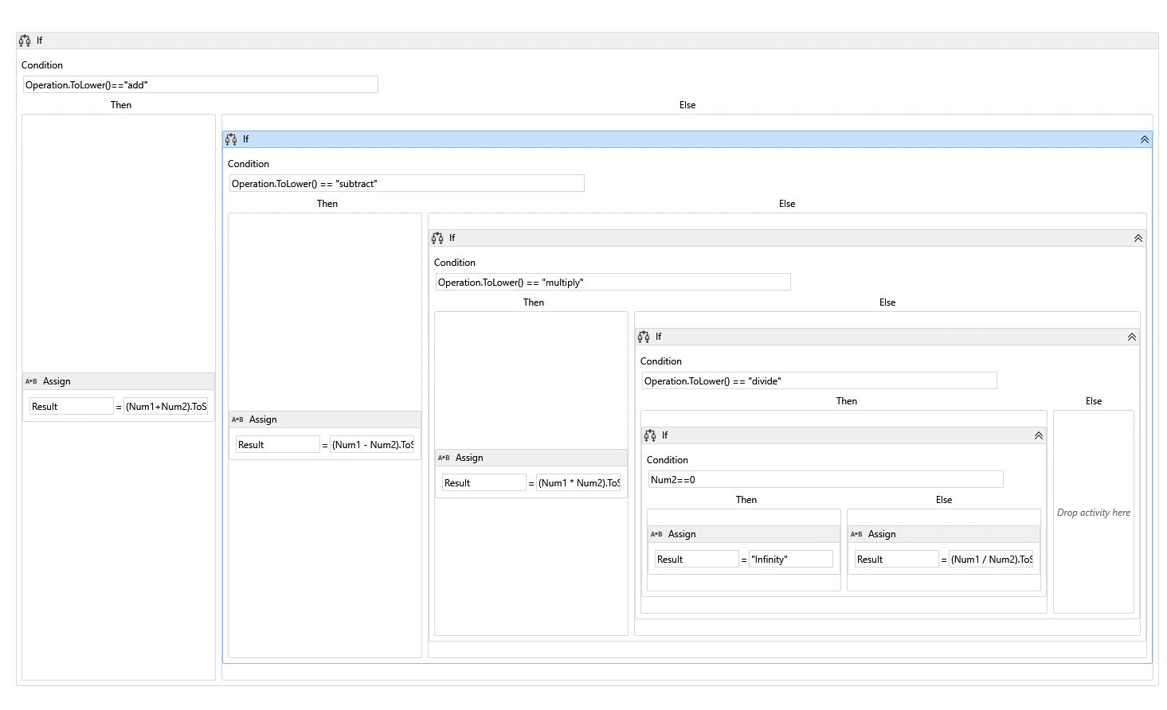

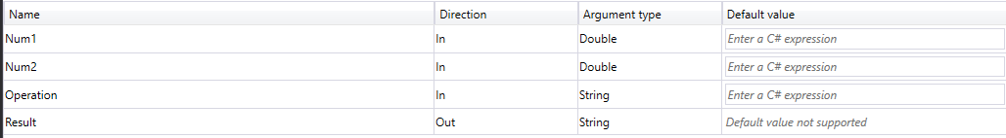

**Testing in Console App:**

class Program

{

static void Main(string[] args)

{

Workflow1 workflow = new Workflow1();

Console.WriteLine("Enter the first number:");

double num1 = Convert.ToDouble(Console.ReadLine());

Console.WriteLine("Enter the second number:");

double num2 = Convert.ToDouble(Console.ReadLine());

Console.WriteLine("Enter the operation:");

string operation = Console.ReadLine();

workflow.Num1 = num1;

workflow.Num2 = num2;

workflow.Operation = operation;

IDictionary<string, object> result = WorkflowInvoker.Invoke(workflow);

Console.WriteLine("Result: " + result["Result"]);

}

}

**Output:**

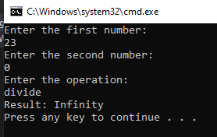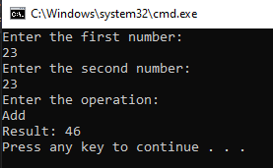

**Task # 02: Create a workflow for any real world problem and test the asp.net mvc application using that workflow.**

**Solution:**

**Note:** Fee Challan Generation Scenario is chosen for this task. Fee challan will be generated w.r.t. class and naval or civil category.

**Workflow:**

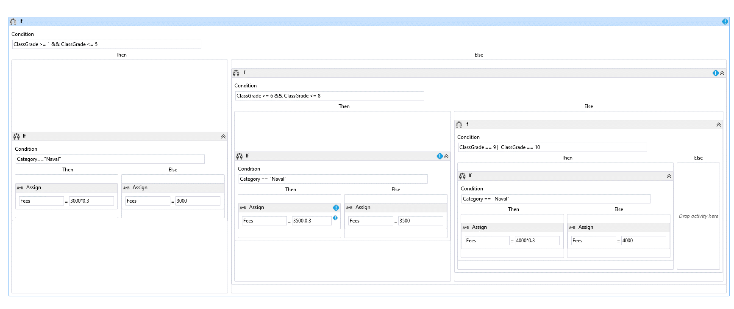 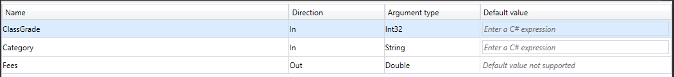

**FeeChalanController:**

using FeeWorkFlow;

using System;

using System.Activities;

using System.Collections.Generic;

using System.Linq;

using System.Web;

using System.Web.Mvc;

using WorkFlow_Task2.Models;

namespace WorkFlow_Task2.Controllers

{

public class FeeChalanController : Controller

{

// GET: FeeChalan

public ActionResult Index()

{

return View();

}

[HttpPost]

public ActionResult GenerateChalan(FeeChalan model)

{

int classGrade = int.Parse(model.ClassGrade);

string category = model.Category;

Workflow1 workflow = new Workflow1();

workflow.ClassGrade = int.Parse(model.ClassGrade);

workflow.Category = model.Category;

IDictionary<string, object> result = WorkflowInvoker.Invoke(workflow);

double fees = (double)result["Fees"];

model.Fees = fees;

return View(model);

}

}

}

**Index.cshtml Code:**

@model WorkFlow_Task2.Models.FeeChalan

@{

ViewBag.Title = "Index";

}

<h2>Details</h2>

@using (Html.BeginForm("GenerateChalan", "FeeChalan", FormMethod.Post))

{

<div class="container-fluid"> <div class="form-group"> @Html.LabelFor(f => f.RollNo, "Enter Roll No:")

@Html.TextBoxFor(f => f.RollNo, new { type = "number" })

</div><div class="form-group">

@Html.LabelFor(f => f.Name, "Enter Name:")

@Html.TextBoxFor(f => f.Name)</div> <div class="form-group"><label>Select Class:</label>

@Html.DropDownListFor(f => f.ClassGrade, Enumerable.Range(1, 10).Select(x => new SelectListItem { Text = x.ToString(), Value = x.ToString() }), "-- Select --", new { @class = "form-control", style = "display:inline-block" })</div> <div class="form-group">

<label>Select Category:</label>

@Html.DropDownListFor(f => f.Category, new List<SelectListItem>

{

new SelectListItem { Text = "Naval", Value = "Naval" },

new SelectListItem { Text = "Civil", Value = "Civil" }

}, "-- Select --", new { @class = "form-control", style = "display:inline-block" })

</div>

<button class="form-group" type="submit">Login</button>

</div>

}

**GenerateChalan.cshtml Code:**

@model WorkFlow_Task2.Models.FeeChalan

@{

ViewBag.Title = "GenerateChalan";

}

<h2>Fee Chalan</h2>

<div><label>Roll No:</label><span>@Model.RollNo</span></div>

<div><label>Name:</label><span>@Model.Name</span></div>

<div><label>Class Grade:</label><span>@Model.ClassGrade</span></div>

<div><label>Category:</label><span>@Model.Category</span></div>

<div> <label>Fees:</label><span>@Model.Fees</span></div>

**Output:**

